11.30 - 12.30 Session 6. Moderator: Mikhail B. Konashev
Boreyko Anton Vladimirovich. "Collapse" of the USSR and "Perestroika" in Cuba: a "Special period" as an Alternative to
the restoration of capitalism (1991-2000)
Koppe Renate. The growth of anti-communism and Russo phobia in the Politics of German Imperialism as a Result of the Collapse of
the USSR
Pavlenko Vladimir Borisovich. The USSR, People’s Democratic Countries and Modern Russo - Chinese Alliance as Alternative Projects for the Historical Development of and for the XX-XXI Centuries

12.30—12.40. Recess

12.40 - 13.40. Session 7. Moderator: Mikhail B. Konashev
Arkhangelsky Vladimir Alekseevich. To Meet the Actual Crisis in Sociology is but Essential Condition for the Future Success for
the Doers, carrying Common Interests of the Humankind.
Filimonova Tatiana Ivanovna. "Our Party": on a Special Role of the Communist Party in a Social and Socialist Transformation of
the Society
Gafurov Said Zakirovich. The Global Nature of Modern Capitalism and the Class Struggle in the Countries of the Former USSR

13.40 – 14.40. Lunch

14.40 - 17.00. Round Table. Discussions.
Moderator: Tatiana I. Filimonova

Temporal regulations: Presentations - 15 min; Questions - 5 min; Reviews – a 5 min speech
Presentations at the Round table
Key-speakers: 10 min, a 5 min finalizing talk

National Library of Russia
Plekhanov House
Association for Marxist Social Sciences
Rosa Luxemburg Foundation

The International Scientific Conference

«Soviet Union: An Alternative of the Past, or a Strategic Project for the Future?»

PROGRAMME

12-13November, 2021
St.-Petersburg

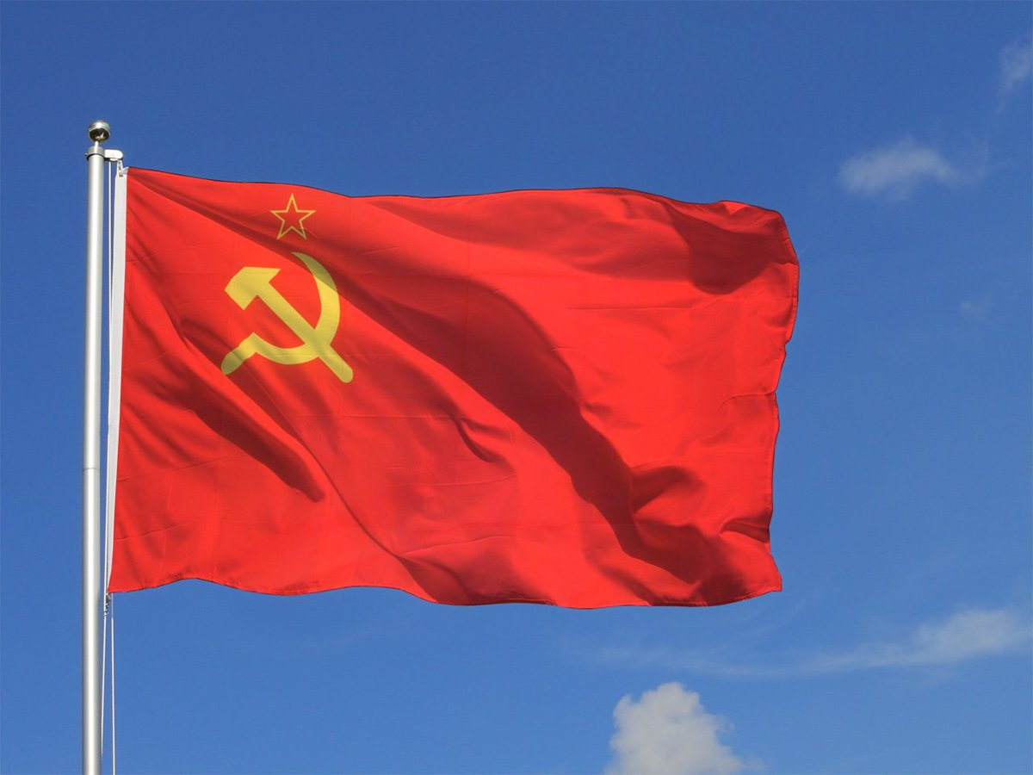

12 November, 2021 г.
9.30 – 09.50. Registration. Plekhanov House,
4-th Krasnoarmeysraya str. 1/33, Petersburg (Technological Institute metro st.)
09.50 - 11.20. Session 1. Moderator: Tatyana I. Filimonova.
Greetings: Vladimir GhennadievichGronsky, Gen. Director of the NLR
Michael-Matsas Savas. USSR and Imperialism: Back to the Future
Savran Sungur. The USSR: Nationless Federation of Nations
Schiappa Jean-Marc. Commune de Paris, “The State and Revolution” and the USSR
Buzgalin Alexander Vladimirovich. Citizens’ Social Creativity as
the Justification for the Development of the USSR

11.20—11.30. Recess

11.30 - 12.50 Session 2. Moderator: Mikhail B. Konashev
Apanasenko Tatyana Evgenievna. The Soviet Economic Model for Substituting Exploitation and Incorporating Costs as a Guideline for the Future
Oreshnikov Vladimir Vyacheslavovich. USSR as the Result of the Great Socio-Economic Revolution, Carried Out Prior to Setting Up Necessary Economic Basis
Ogorodnikov Vladimir Petrovich. Objective Laws for the Development and of the Fall of the USSR
Pilipenko Igor Valerievich. The Dynamics of Residence Construction and the Solution of the Dwelling issue in the Republics of the USSR, 1920-1980

12.50—13.30. Recess

13.00 - 14.00. Session 3. Moderator: Mikhail B. Konashev
Kalous Antal. Anti-Sovietism in the Pre-war Period
Beolchi Luciano. The Break-up of the antifascist front. Origins of the Cold War in Italy (1945-1950).
Ossin Roman Sergueevich. Stalin's Argument about Class Struggle Aggravation Under Socialist Conditions and the Experience of
the Soviet society

14.00 – 15.00. Lunch

15.00 – 16.20. Session 4. Moderator: Tatyana I. Filimonova

Abramson Joseph Grigorievich. A combination of objective and subjective factors that led to the End of the Soviet Union
Epstein David Berkovich. Contradictions of the Socio-Economic Nature of the USSR and Causes of its Perishing
Kurenyshev Andrei Alexandrovich. On the Pitfalls that Eroded
the USSR
Konashev Mikhail Borisovich. On Some Economic and Philosophical Aspects of the Evolution of the USSR

16.20—16.30. Recess

16.50-17.30. Discussions. Moderator: Mikhail B. Konashev

13 November, 2021 г.
Plekhanov House, 1/33, 4-th Krasnoarmeysraya str., Saint-Petersburg (Technological Institute metro st.)

10.00 - 11.20. Session 5. Moderator: Tatiana Ivanovna Filimonova
Bugakov Mikhail Mikhailovich. The Lithuanian Irony of
the “Perestroika"
Retinsky Stanislav Grigorievich. The Defeat of Socialism in the USSR and the Party as the Class Conscience carrier
Mavroudeas Stavros D. Soviet Union: A Socio-economic Type, Collapse and Lessons for the Future
Isaichikov Viktor Fedorovich. Is It Possible to “Come back” to
the USSR, Under What Conditions, and to What Type of the Union?

11.20—11.30. Recess

